Cardiovascular Disease Risk Screening from
Routine Examination Data: A Leak-Free Benchmark
of Five Classiﬁers with Physiological Data Cleaning
Abstract—Routine outpatient examinations record blood pres- (age in years, BMI, pulse pressure) and an ablation of their
sure, anthropometry, and basic laboratory and lifestyle variables, value; (iii) a leak-free comparison of ﬁve standard classiﬁers
yet public examination registries contain implausible entries that
with confusion matrices, speciﬁcity and ROC/PR curves; and
(iv) a candid analysis of how far the differences between
models, and the feature-importance ranking, can be trusted.
can distort model training. This paper benchmarks ﬁve super-
vised classiﬁers on a public cohort of 70,000 examination records.
A rule-based physiological ﬁlter removes 1,387 records (1.98%),
leaving 68,613 records with near-balanced classes (49.47% pos- Section II reviews related work, Section III describes the
itive). Age in years, body mass index and pulse pressure are method, Section IV the experimental setup, Section V the
derived, and all models are evaluated on a stratiﬁed 20% held-
results, and Sections VI and VII limitations and conclusions.
out set (n = 13,723) with scaling ﬁtted on training data only.
A random forest obtains the highest accuracy (73.30%), ROC-
AUC (0.8003), precision (76.20%) and speciﬁcity (79.54%), but
its margin over logistic regression, a decision tree, a calibrated
linear SVM and k-NN is under one percentage point in accuracy
II. RELATED WORK
Classical risk equations such as the Framingham general
and lies within the sampling uncertainty of a single split. Blood- cardiovascular risk proﬁle [3] combine a small set of risk
pressure variables dominate Gini importance (64.77% combined,
factors in a regression model and are valued for transparency.
Machine-learning studies instead let ﬂexible models capture
non-linear interactions. Mohan et al. combined a random forest
including the derived pulse pressure). Derived features raise
random-forest ROC-AUC from 0.7932 to 0.8003. We discuss why
importance shares should not be read as evidence of arterial
stiffness, and list the validity limits of a single-split, cross-sectional with a linear model for heart disease prediction on a small
evaluation.
clinical dataset [4], illustrating the appeal of hybrid learners
on tabular medical data.
The dataset used here has been employed in several com-
parisons. Sadr et al. evaluated an ensemble that votes among
a CNN, an LSTM, k-NN and XGBoost on this 70,000-record
Index Terms—cardiovascular disease, supervised learning, ran-
dom forest, data cleaning, pulse pressure, feature importance
I. INTRODUCTION
Cardiovascular diseases (CVDs) are the leading cause of dataset together with two other datasets, and reported the
death worldwide; the World Health Organization estimates best performance of their proposed combination across all
19.8 million CVD deaths in 2022, about 32% of all deaths, datasets [5]. Their emphasis is on model integration; our study
with over three quarters occurring in low- and middle-income asks a complementary question about how much simple, well-
countries [1]. The same source stresses that intermediate risk controlled classical models already achieve once the data are
factors such as raised blood pressure, glucose, lipids and cleaned and evaluated without leakage.
excess weight can be measured in primary care, and that early
Pulse pressure, the difference between systolic and dias-
detection allows management to begin sooner. Cheap, non- tolic pressure, was examined in the Framingham cohort as a
invasive tabular screening models are therefore of practical predictor of coronary heart disease risk [6], which motivates
interest.
including it as an engineered feature. Table I summarizes how
Two obstacles recur when such models are built from public these studies relate to this work.
examination data. First, the data are not clean: the widely used
Three themes from this literature shape our design. First,
70,000-record cardiovascular examination dataset [2] contains most reported accuracies on this dataset are tied to a speciﬁc
blood-pressure values that are physiologically impossible, and cleaning rule and split, so claims that one algorithm beats
ﬁltering rules differ between studies, so reported accuracies another are only meaningful when preprocessing and evalua-
are hard to compare. Second, benchmark comparisons often tion are controlled; we therefore hold both ﬁxed. Second, tree
differ in preprocessing, split protocol and reported metrics, ensembles are often preferred for tabular medical data because
which makes small accuracy differences between algorithms they handle non-linear interactions and mixed feature types
difﬁcult to interpret.
without extensive tuning [4], [7], but their built-in importance
This paper does not propose a new algorithm. It is an scores are known to favour variables with many possible split
engineering and benchmarking study with four concrete con- points and to spread credit among correlated predictors [8],
tributions: (i) an explicit, reproducible physiological ﬁlter and which affects how importance results can be read. Third, risk
its effect on the cohort; (ii) three derived clinical variables tools intended for clinical use are judged on calibration as

TABLE I
TABLE II
VERIFIED PRIOR STUDIES AND THEIR RELATION TO THIS WORK
PHYSIOLOGICAL FILTER RULES AND RATIONALE
Ref.
[3]
Method / data
Relation to this study
Variable
Retained range
60–240 mmHg
Rationale
Regression risk proﬁle, Transparent
Framingham cohort
baseline
Systolic (ap hi)
Excludes negative and
mistyped values, keeps
severe hypertension
Same
Pulse pressure must be pos-
itive
paradigm; we use no survival
outcome
[4]
[5]
Hybrid random forest Supports tree-ensemble use on
+ linear model, clinical tabular data; different dataset
heart data
CNN+LSTM+k-
NN+XGB
70,000-record
among others
Diastolic (ap lo) 40–160 mmHg
Ordering
ap hi > ap lo
Same dataset; heavier models,
voting; we focus on cleaning and con-
data trolled comparison
Height
Weight
120–220 cm
30–200 kg
Plausible adult stature
Plausible adult mass
[6]
Pulse pressure and coro- Motivates pulse-pressure fea-
nary risk, Framingham ture
recognized correlate of large-artery stiffness and was examined
as a coronary risk predictor in the Framingham cohort [6];
BMI condenses height and weight into a single adiposity
index, which is a standard clinical summary. Together with the
original variables (sex, height, weight, systolic and diastolic
pressure, cholesterol and glucose categories, smoking, alcohol,
physical activity), the model input has 13 features.
Physiological
Derived
features
3 added
Raw cohort
70,000
ﬁlter
68,613
Stratiﬁed
80/20 split
Scale on
train only
5 classiﬁers
ﬁt on train
D. Classiﬁers
Five standard models from scikit-learn [9] are compared:
L2-regularized logistic regression; k-NN with k = 25 and
Euclidean distance [10]; a decision tree with maximum depth
10; a random forest of 100 trees with maximum depth 12 [7];
and a linear support vector machine [11] whose scores are
converted to probabilities by sigmoid (Platt) calibration [12].
Binary predictions use a probability threshold of 0.5. Hyper-
parameters are ﬁxed values; no tuning procedure or separate
validation split is documented in the supplied materials, and
the test set was used both for model ranking and for reporting.
Evaluate on held-
out n 13,723
metrics, curves, importance
=
Fig. 1. Workﬂow of the benchmark. Counts are numbers of records.
well as discrimination [3]; we consequently state clearly that
calibration was not evaluated in the supplied results.
III. METHOD
A. Pipeline Overview
E. Formal Description of the Learners
Fig. 1 shows the workﬂow: ingestion, physiological ﬁltering,
feature derivation, a stratiﬁed split with training-only scaling,
benchmarking of ﬁve classiﬁers, and evaluation on the held-
out set.
Let x ∈ R¹³ be the standardized feature vector and y ∈
i
i
{0, 1} the label of record i. Each learner produces a score
pˆ ≈ P(y = 1 | x ) and the predicted label is yˆ = ⊮[pˆ ≥ τ]
i
i
i
i
i
with τ = 0.5.
Logistic regression models pˆ = σ(w⊤x+b) and minimizes
the regularized log-loss
B. Physiological Filtering
A record is retained only if all conditions in (1) hold:
X^{m}
ꢀ
ꢁ
1
60 ≤ ap hi ≤ 240, 40 ≤ ap lo ≤ 160, ap hi > ap lo,
ℓ y , σ(w⊤x + b) + λ∥w∥²,
(2)
min
w,b
i
i
2
m
120 ≤ height ≤ 220 cm, 30 ≤ weight ≤ 200 kg.
i=1
(1)
where m is the training size. k-NN assigns the majority label
among the k = 25 nearest training records. A decision tree
chooses at each node the split that most reduces the Gini
Pressures are in mmHg. The bounds are deliberately wide so
that severe but plausible hypertension is kept; only entries that
are impossible or inverted (systolic not above diastolic) are
removed. The ﬁlter removes 1,387 of 70,000 records (1.98%).
The bounds were set from clinical plausibility; the supplied
materials do not show whether they were tuned against model
performance.
P
impurity G = 1 −
p², and a random forest averages
c
c
B = 100 such trees grown on bootstrap samples with random
feature subsets at each split [7]. The impurity importance
of feature j is the total impurity decrease from splits on j,
weighted by node size and averaged over trees,
C. Derived Features
X^{B}
X
1
^{n}t
(3)
^{MDI}j ⁼
^{∆G}t,
Age is converted from days to years, age years
round(age/365.25, 1). Body mass index is BMI
=
=
B
n
b=1 t∈T : v(t)=j
b
weight/(height/100)² in kg/m², and pulse pressure is ∆P = normalized to sum to one. The linear SVM ﬁnds a maximum-
ap hi − ap lo. Pulse pressure is included because it is a margin hyperplane [11]; its decision value f(x) is mapped to
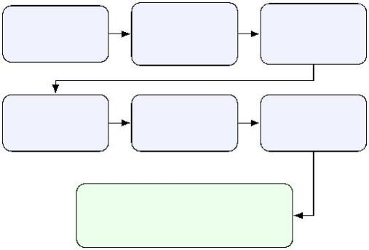

TABLE III
MODEL SETTINGS USED IN THE BENCHMARK
Model
Settings as reported
Logistic regression
L2 penalty; regularization strength not
recorded
k-NN
k
=
25, Euclidean distance, standardized
inputs
Decision tree
Random forest
Linear SVM
Gini criterion, maximum depth 10
100 trees, maximum depth 12, Gini criterion
Linear
kernel,
sigmoid
calibration
(CalibratedClassifierCV); number of
folds not recorded
Threshold 0.5; seed and library versions not
recorded
Fig. 2. (a) Class distribution and (b) age density by diagnosis in the cleaned
cohort.
All
TABLE IV
DESCRIPTIVE STATISTICS OF THE CLEANED COHORT (N = 68,613)
Feature
Unit
Mean ± SD
Range
r
age years
gender (1 F, 2 M)
height
years
–
cm
kg
53.3 ± 6.8
1.35 ± 0.48
164.4 ± 7.9
74.1 ± 14.3
29.6–64.9
1–2
+0.239
+0.007
−0.012
+0.180
+0.428
+0.341
+0.337
+0.190
+0.221
+0.090
−0.038
120–220
30–200
60–240
40–160
1–160
10.7–108.6
1–3
weight
ap hi
ap lo
pulse pressure
BMI
cholesterol (1–3)
glucose (1–3)
active
mmHg 126.7 ± 16.7
mmHg
mmHg
kg/m²
level
81.4 ± 9.8
45.3 ± 12.0
27.5 ± 5.2
Fig. 3. Observed disease prevalence by (a) age decade and (b) BMI category.
1.36 ± 0.68
1.23 ± 0.57
0.804 ± 0.40
level
binary
1–3
0–1
B. Protocol and Metrics
a probability by Platt scaling, pˆ = 1/(1 + exp(Af(x) + B)),
with A, B ﬁtted on held-out folds inside the training set by
CalibratedClassifierCV [12].
The cleaned data are split 80/20 with stratiﬁcation on the
label, giving N_{train} = 54,890 and N_{test} = 13,723 (6,934
negative, 6,789 positive). A StandardScaler is ﬁtted on
the training features only and applied to the test features, so
no test statistics enter training. With TP, TN, FP and FN the
confusion-matrix counts, we report accuracy = (TP+TN)/n,
precision = TP/(TP + FP), recall = TP/(TP + FN),
speciﬁcity = TN/(TN+FP), F1 (harmonic mean of precision
and recall) and ROC-AUC, the probability that a random pos-
itive record scores higher than a random negative one. From
the counts we also derive negative predictive value (NPV),
balanced accuracy and the Matthews correlation coefﬁcient,
IV. DATASET AND EXPERIMENTAL SETUP
A. Data
The cohort comes from the public Kaggle cardiovascular
dataset [2]: 70,000 examinations, no missing values, and a
binary label cardio (disease present). After ﬁltering, 34,671
records are negative (50.53%) and 33,942 positive (49.47%)
(Fig. 2a). Table IV gives descriptive statistics and the Pearson
correlation of each feature with the label.
Blood pressure shows the clearest univariate association
with the label (Fig. 4); prevalence also rises steeply with
age decade and BMI category (Fig. 3). The BMI range in
Table IV (minimum 10.7, maximum 108.6) shows that the
ﬁlter on height and weight still admits extreme BMI values;
these were retained.
Fig. 5 makes the redundancy among inputs explicit. BMI
correlates 0.86 with weight, pulse pressure 0.84 with systolic
pressure, and systolic with diastolic pressure 0.73. Smaller
links exist between height and sex (0.52) and between choles-
TP · TN − FP · FN
(TP + FP)(TP + FN)(TN + FP)(TN + FN)
MCC = p
,
(4)
which summarizes all four cells in one number. Precision–
recall curves show threshold behaviour. Python with scikit-
learn [9] was used. The random seed and library versions
are not recorded in the supplied materials, which limits exact
reproducibility.
As an additional analysis, we computed 95% Wilson score
terol and glucose categories (0.45). No feature correlates with intervals [13] for test accuracy from the reported confusion-
the label above 0.43, so no single measurement reproduces matrix counts, and a Hanley–McNeil standard error [14] for
the label, which anticipates a modest ceiling on discrimina- the random-forest AUC. These quantify sampling uncertainty
tion. The redundancy matters for the importance analysis in of the test set only; they do not capture variation from the
Section V-C.
choice of split or random seed.
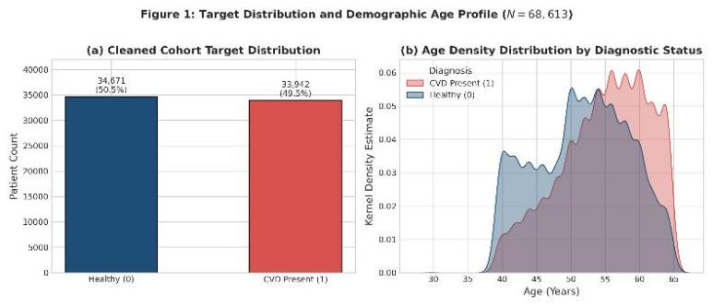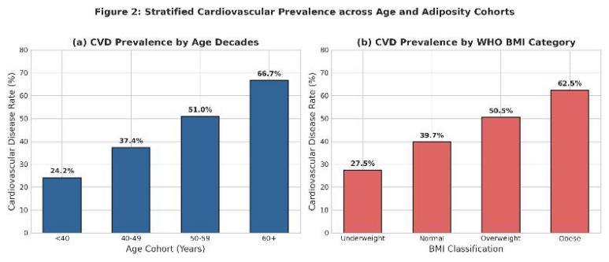

Fig. 4. Systolic, diastolic and pulse pressure by diagnosis.
TABLE V
TEST-SET PERFORMANCE (n = 13,723)
Model
Acc. % Prec. % Rec. % Spec. %
F1
AUC
Random forest
Decision tree
Logistic reg.
73.30 76.20 66.93 79.54 0.7127 0.8003
72.89 74.29 69.13 76.58 0.7162 0.7917
72.72 75.56 66.31 79.00 0.7064 0.7893
Linear SVM (cal.) 72.70 75.45 66.42 78.84 0.7065 0.7893
k-NN (k=25) 72.58 74.14 68.45 76.62 0.7118 0.7865
Fig. 6. Threshold-based metrics of the ﬁve classiﬁers on the test set (values
from Table V).
Fig. 5. Pearson correlation matrix of the features and the label (values as
annotated in the ﬁgure).
V. RESULTS AND DISCUSSION
the same test records, a paired test would be more sensitive
than overlapping intervals, but per-record predictions are not
available to us. The defensible conclusion is that the ﬁve
models perform similarly on this feature set, with the random
forest nominally best, not that it is demonstrably superior. The
ROC curves in Fig. 8 are nearly superimposed, which supports
this reading and suggests the achievable discrimination is
limited by the information in the features rather than by model
family.
A. Model Comparison
Table V and Fig. 6 compare the ﬁve classiﬁers; Fig. 7
gives the underlying confusion matrices, from which every
threshold-based metric in the table can be recomputed. The
random forest ranks ﬁrst on accuracy, precision, speciﬁcity
and AUC. The decision tree has the highest recall (69.13%)
and F1 (0.7162), and k-NN the second highest recall, so the
ranking depends on the metric.
The gaps are small. Accuracy ranges from 72.58% to
73.30%, a spread of 0.72 points. The 95% Wilson intervals
Table VII reports metrics derived from the same confusion
(Table VI) are about ±0.75 points wide and overlap almost matrices. MCC varies only between 0.452 and 0.469, again
completely, and the Hanley–McNeil standard error of the a tiny spread. The negative predictive value of 70.6–71.7%
random-forest AUC is about 0.004 (approximate 95% interval means that roughly three in ten records classiﬁed as healthy
0.793–0.808), which already covers the AUCs of the decision carry the disease label, an important caveat if a model were
tree and linear models. Because all models are scored on used to reassure patients.
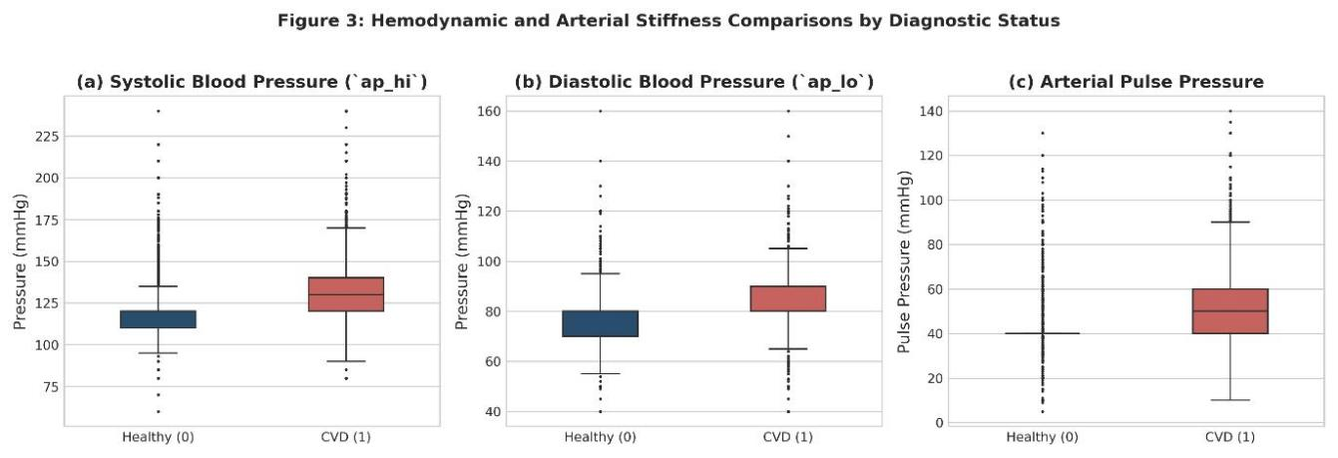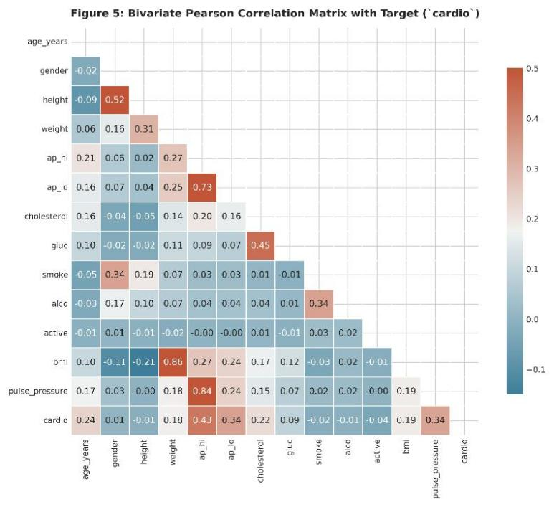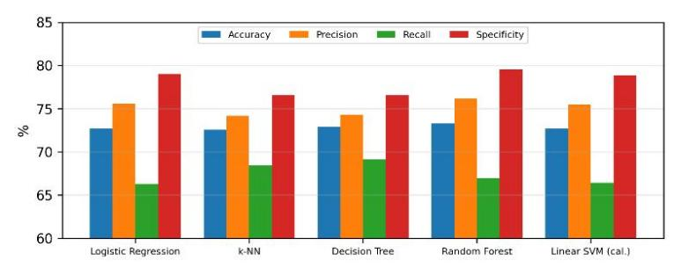

Fig. 7. Test-set confusion matrices (rows: true class, columns: predicted class).
Fig. 8. (a) ROC and (b) precision–recall curves on the test set.
TABLE VI
95% WILSON INTERVALS FOR TEST ACCURACY
Model
Accuracy (%)
95% CI
Random forest
Decision tree
Logistic regression
Linear SVM (cal.)
k-NN
73.30
72.89
72.72
72.70
72.58
72.55–74.03
72.14–73.63
71.97–73.46
71.94–73.43
71.83–73.32
Fig. 9. Random-forest ablation (values from Table VIII); note the truncated
vertical axes, which exaggerate small differences.
TABLE VII
ADDITIONAL METRICS DERIVED FROM THE CONFUSION MATRICES
Model
NPV % Bal. acc. %
MCC
FN / FP
comparable to the test-set sampling uncertainty above, and
come from one split. They should be treated as suggestive.
This is also expected on structural grounds: BMI and pulse
pressure are deterministic functions of existing inputs, so they
cannot add information, only make useful interactions easier
for depth-limited trees to express. The supplied materials
do not state exactly which columns the “raw” conﬁguration
contains (for example, whether age was already in years), so
the ablation is reported as supplied.
Random forest
Decision tree
Logistic reg.
Linear SVM (cal.)
k-NN
71.07
71.70
70.55
70.57
71.27
73.23
72.85
72.66
72.63
72.54
0.469 2245 / 1419
0.459 2096 / 1624
0.457 2287 / 1456
0.456 2280 / 1467
0.452 2142 / 1621
B. Effect of Derived Features
Table VIII shows a random-forest ablation. Adding BMI
raises ROC-AUC from 0.7932 to 0.7965, and adding pulse
pressure as well raises it to 0.8003, with accuracy rising
from 72.81% to 73.30%. The improvements are consistent in
C. Feature Importance
Mean decrease in impurity (Gini) importances of the ran-
direction but small (about 0.7 points of accuracy in total), dom forest are shown in Fig. 10 and Table IX. Systolic pres-
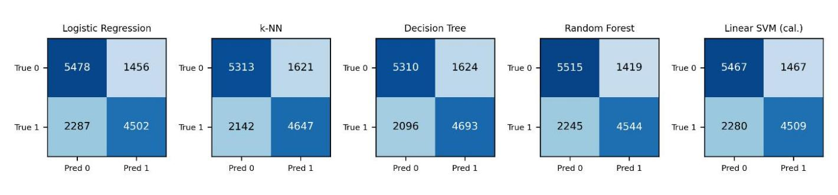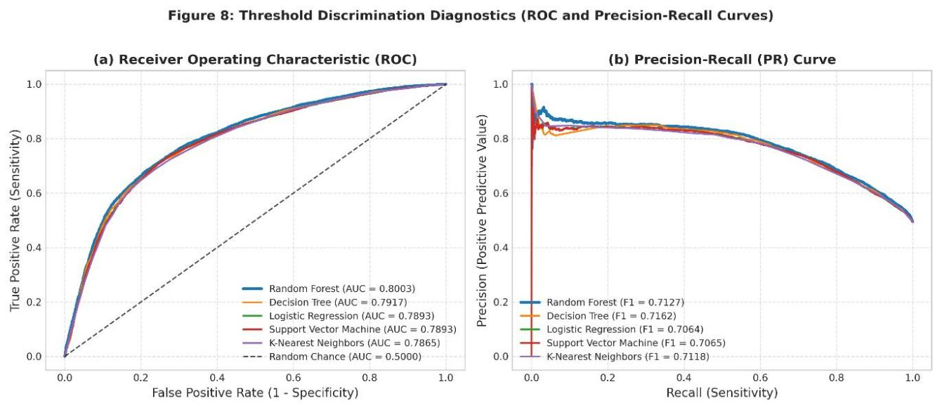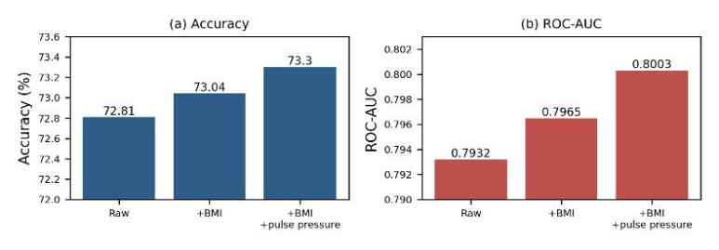

TABLE VIII
RANDOM-FOREST FEATURE ABLATION (TEST SET)
Conﬁguration
Acc. % Prec. %
F1
AUC
Raw features
72.81
73.04
73.30
75.32
75.78
76.20
0.7065 0.7932
0.7093 0.7965
0.7127 0.8003
+ BMI
+ BMI + pulse pressure
TABLE IX
GINI IMPORTANCE OF THE RANDOM FOREST
Feature
%
Feature
%
ap hi
ap lo
34.06 weight
17.27 height
3.96
2.63
1.10
0.77
0.46
Fig. 10. Gini importance of the random forest.
pulse pressure 13.44 glucose
age years
cholesterol
BMI
12.11 active
8.22
5.32
gender
TABLE X
smoke / alcohol 0.40 / 0.26
EXPECTED OUTCOMES PER 1,000 EXAMINEES (ROUNDED)
Model
TP
FN
FP
TN
sure (34.06%), diastolic pressure (17.27%) and pulse pressure
(13.44%) sum to 64.77%, followed by age (12.11%) and
cholesterol (8.22%). Smoking, alcohol and sex each contribute
under 0.5%; smoking, alcohol and physical activity together
contribute 1.43%.
This ranking agrees with the univariate correlations in Ta-
ble IV, but it should be interpreted cautiously. Pulse pressure is
the exact difference of the two pressure variables, and BMI is a
function of height and weight, so importance is divided among
correlated and algebraically related features, and impurity-
based importance is known to be biased in such settings [8].
Adding the three pressure shares to obtain “64.77% hemo-
dynamic importance” therefore counts one underlying signal
through three overlapping columns. Importance also measures
how a model uses a feature, not a causal or physiological
Random forest
Decision tree
331 164 103 402
342 153 118 387
Logistic regression 328 167 106 399
to a population with this prevalence; screening populations
in practice usually have much lower prevalence, where the
share of false positives among all ﬂagged cases would be
considerably larger.
The decision tree ﬁnds about 11 more true cases per 1,000
than the random forest but raises about 15 more false alarms,
while logistic regression misses about 3 more cases than the
forest. Which trade is preferable is a clinical and economic
decision, not a statistical one, and it is one reason a single
accuracy ﬁgure is an inadequate summary.
mechanism, so these results do not by themselves demon- F. Why Performance Plateaus
strate arterial stiffness as the driver of disease. Permutation
importance on held-out data, or grouped importance, would
be better-suited checks and remain future work.
Several explanations for the narrow band of results are
consistent with the evidence, although none is tested here. The
inputs omit established determinants of cardiovascular disease,
such as lipid sub-fractions, family history, medication use
and imaging; the label may contain noise because its clinical
derivation is not documented; and blood pressure was taken
at a single examination, so it carries measurement variability.
Because ﬁve very different learners converge to the same
discrimination, additional model complexity on these same
13 inputs is unlikely to help, and gains are more plausibly
obtained from better or additional measurements and from a
cleaner reference label. This is a hypothesis for future work
rather than a ﬁnding.
D. Error Proﬁle
At the default threshold the random forest produces 1,419
false positives and 2,245 false negatives (Fig. 7). It therefore
misses about one third of positive cases (recall 66.93%) while
keeping speciﬁcity near 80%. For a screening use, where
missed cases are costlier than extra referrals, the default
threshold is probably not the right operating point, and the
precision–recall curve in Fig. 8b shows that precision falls
gradually as recall is increased. The supplied drafts quote
a lower threshold giving recall above 85%, but no result
ﬁle supports that ﬁgure, so we do not report it; choosing a
threshold on a validation set is left for future work.
G. Practical Interpretation
Two observations matter for anyone considering such a
model in primary care. First, the near-identical behaviour of
logistic regression and a 100-tree forest means the simplest,
E. What the Counts Mean per 1,000 Screened
To make the error proﬁle concrete, Table X scales the test most auditable model gives up little on this feature set: its
confusion matrices to 1,000 screened examinees at the cohort’s accuracy is 0.58 points lower and its AUC 0.011 lower, while
roughly even class balance (about 495 labelled positive). The keeping directly readable coefﬁcients. Where auditability is
numbers are simple rescalings of Fig. 7 and apply only valued, the linear model is a sensible default, and the forest’s
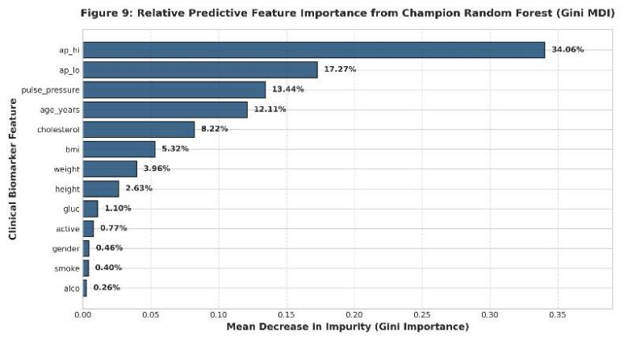

edge would need conﬁrmation on repeated splits before it
justiﬁes extra complexity. Second, both the ﬁlter and the
derived variables are cheap to compute from a routine visit, so
the pipeline could be reproduced in low-resource settings. Ye t
an accuracy near 73% with recall near two thirds is a screening
aid at best; it cannot replace clinical assessment, and the 2,245
missed cases in the held-out set must be weighed against the
1,419 unnecessary referrals when choosing a threshold.
TABLE XI
EVIDENCE STATUS OF KEY STATEMENTS
Status
Statements
Recomputed from con- Accuracy, precision, recall, speciﬁcity, F1
fusion matrices
of all ﬁve models; cohort and class counts;
importances sum to 100%
Reported in drafts, not ROC-AUC values, ablation results, impor-
regenerated
tance values, descriptive statistics, curves
Wilson intervals, AUC standard error, NPV,
balanced accuracy, MCC
Newly derived here
H. Reproducibility
Removed as unsup- Recall above 85% at
τ = 0.38, dashboard
ported
and simulated-patient demonstration, hy-
perparameter tuning, claims that cleaning
stabilizes training in other work
The materials supplied for this study were earlier manuscript
drafts and their ﬁgures; source code, notebooks, split indices
and model ﬁles were not available. The numbers here are
therefore those reported in the drafts. Their internal consis-
tency was checked: accuracy, precision, recall, speciﬁcity and
F1 for all ﬁve models were recomputed from the reported
confusion matrices and agree with the tables, the cohort and
class counts are mutually consistent, and the importances sum a diagnostic tool.
to 100%. They have not been regenerated from raw data. The
essentials for reproduction are ﬁxed in this paper: the ﬁlter in
Eq. (1), the feature deﬁnitions, the split sizes, training-only
scaling and the model settings of Section III-D. Seeds and
library versions must be added by the holder of the code.
not evaluated here, no claim of equitable performance can be
made.
Use. The model has not been clinically validated and is not
VII. SUMMARY OF EVIDENCE STATUS
Because the underlying code and data were not supplied,
Table XI states which statements in this paper are veriﬁed
by recomputation, which come from the earlier drafts without
independent regeneration, and which were removed.
VI. LIMITATIONS AND THREATS TO VALIDITY
VIII. CONCLUSION AND FUTURE WORK
Evaluation design. All results come from a single stratiﬁed
split without repeated runs, cross-validation or a separate
On a physiologically ﬁltered cohort of 68,613 examina-
validation set, and the same test set was used to rank models. tion records, ﬁve standard classiﬁers reach 72.6–73.3% test
The random seed was not recorded. Differences below about accuracy and ROC-AUC between 0.787 and 0.800, with the
one point should not be over-interpreted.
random forest nominally best. The differences between models
Data. The label is a binary “disease present” indicator are small relative to test-set uncertainty, and the ROC curves
whose clinical deﬁnition and collection protocol are not doc- nearly coincide, indicating a ceiling imposed by the available
umented; the measurements are cross-sectional, so the task is non-invasive features. Derived BMI and pulse pressure give
detection of existing disease signals, not prediction of future a small, consistent gain in the random forest, and blood-
events. Lifestyle variables are self-reported. The dataset is pressure variables dominate its impurity importances, though
from a single source, with a narrow age range (about 30– correlated features limit how this can be interpreted. The
65 years), so generalization to other populations, devices and main practical contributions are the explicit cleaning rules,
clinics is untested. Residual implausible values remain (BMI the leak-free protocol, and a transparent account of what the
up to 108.6, pulse pressure of 1 mmHg). The ﬁlter thresholds comparison can and cannot establish.
were chosen by plausibility, and sensitivity to them was not
Future work should use repeated or nested cross-validation
studied. Blood pressure may also be partly entangled with how with paired signiﬁcance tests, tune hyperparameters on a
the label was assigned, which could inﬂate the apparent value validation set, add gradient-boosted models and permutation-
of those variables.
based importance, assess probability calibration and subgroup
Modelling. Only ﬁve standard classiﬁers with ﬁxed hy- performance, choose screening thresholds explicitly for sensi-
perparameters were compared. Gradient boosting and neural tivity, and validate on an independent clinical cohort.
models, which other studies on this dataset include, were
REFERENCES
not tested, and no probability-calibration quality (for exam-
ple reliability curves or Brier score) was evaluated, so the
probabilities should not be used as clinical risk estimates. No
fairness analysis by sex or age group was performed.
Ethics and fairness. The dataset is a public, de-identiﬁed
table, and no new data were collected. A screening model
trained on one population can systematically under-detect
disease in groups that are under-represented or measured
differently; because subgroup performance by sex and age was
[1] World Health Organization, “Cardiovascular diseases (CVDs):
fact
sheet,”
https://www.who.int/news-room/fact-sheets/detail/
cardiovascular-diseases-(cvds), 2025, accessed: Oct. 27, 2026.
[2] S. Ulianova, “Cardiovascular disease dataset,”
[Online]. Available: https://www.kaggle.com/datasets/sulianova/
Kaggle.
cardiovascular-disease-dataset, 2019.
[3] R. B. D’Agostino, R. S. Vasan, M. J. Pencina, P. A. Wolf, M. Cobain,
J. M. Massaro, and W. B. Kannel, “General cardiovascular risk proﬁle
for use in primary care: the Framingham heart study,” Circulation, vol.
117, no. 6, pp. 743–753, 2008.

[4] S. Mohan, C. Thirumalai, and G. Srivastava, “Effective heart disease
prediction using hybrid machine learning techniques,” IEEE Access,
vol. 7, pp. 81 542–81 554, 2019.
[5] H. Sadr, A. Salari, M. T. Ashoobi, and M. Nazari, “Cardiovascular
disease diagnosis: a holistic approach using the integration of machine
learning and deep learning models,” Eur. J. Med. Res., vol. 29, p. 455,
2024.
[6] S. S. Franklin, S. A. Khan, N. D. Wong, M. G. Larson, and D. Levy,
“Is pulse pressure useful in predicting risk for coronary heart disease?
the Framingham heart study,” Circulation, vol. 100, no. 4, pp. 354–360,
1999.
[7] L. Breiman, “Random forests,” Mach. Learn., vol. 45, no. 1, pp. 5–32,
2001.
[8] C. Strobl, A.-L. Boulesteix, A. Zeileis, and T. Hothorn, “Bias in
random forest variable importance measures: illustrations, sources and
a solution,” BMC Bioinformatics, vol. 8, p. 25, 2007.
[9] F. Pedregosa et al., “Scikit-learn: Machine learning in Python,” J. Mach.
Learn. Res., vol. 12, pp. 2825–2830, 2011.
[10] T. M. Cover and P. E. Hart, “Nearest neighbor pattern classiﬁcation,”
IEEE Trans. Inf. Theory, vol. 13, no. 1, pp. 21–27, 1967.
[11] C. Cortes and V. Vapnik, “Support-vector networks,” Mach. Learn.,
vol. 20, no. 3, pp. 273–297, 1995.
[12] J. C. Platt, “Probabilistic outputs for support vector machines and
comparisons to regularized likelihood methods,” in Advances in Large
Margin Classiﬁers. MIT Press, 1999, pp. 61–74.
[13] E. B. Wilson, “Probable inference, the law of succession, and statistical
inference,” J. Amer. Statist. Assoc., vol. 22, no. 158, pp. 209–212, 1927.
[14] J. A. Hanley and B. J. McNeil, “The meaning and use of the area under
a receiver operating characteristic (ROC) curve,” Radiology, vol. 143,
no. 1, pp. 29–36, 1982.

